Matter and How it Changes - Chapter 13 pages 486-489 Study Guide
Name: ______________________________ Homeroom: _______________
1. Which is heavier – 20 cm³ of lead or 20 cm³ of mercury? Why?____________ _______________________________________________________________
2. How is matter defined? ___________________________________________
3. Define physical property - _________________________________________
_______________________________________________________________
4. [True or False] You can describe the physical property of a magnet as magnetic
5. What are the three physical properties that apply to ALL substances?
1. ______________ 2. ________________ 3. ___________________
6. ____________________ is the amount of mass something has in relation to its volume.
7. ____________________ is the amount of space something takes up.
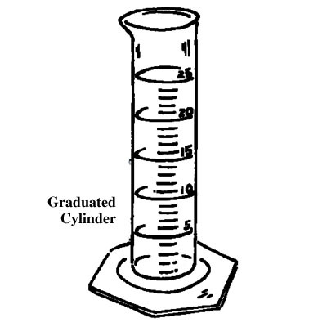
8. ____________________ is the amount of matter something has.
9. What are the two ways mass can be measured?
1. ______________________ 2. ______________________
10. What are the six ways that volume can be measured?
1. ____________ 2. _____________ 3. ____________
4. ____________ 5. _____________ 6. ____________
11. Write the mathematical formula to solve for density.
_____________________________________________________________
12. [True or False] Any substance will float on a liquid that has a lower density than it does.
13. Describe how you could calculate the volume of a rock using the following materials: a rock, a cylinder and water.
_______________________________________________________________ _______________________________________________________________ _______________________________________________________________ _______________________________________________________________14. What is the density of a diamond? __________________________________
15. What is the density of helium? _____________________________________
16. You have two objects both made of solid iron (Fe). Object A has a much greater volume than Object B. How would the densities of the objects compare? Why? ________________________________________________
_______________________________________________________________ _______________________________________________________________ _______________________________________________________________ _______________________________________________________________
17. How do you find the mass of an object? ______________________________
_______________________________________________________________
18. You have a stuffed animal that big, round, fluffy and adorable. Which of the traits mentioned are physical properties? ____________________________
_______________________________________________________________
19. How can you tell that air in a hot air balloon is matter? _________________
______________________________________________________________
20. What happens if you keep breaking a pure substance down into smaller pieces? What do you eventually get? _______________________________
_______________________________________________________________

