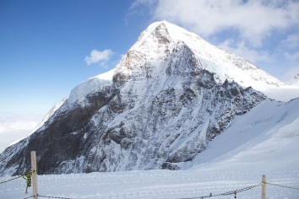
Iceman Article Reviews Questions
Name: _______________________
1. When was the Iceman discovered? (dates) ___________________________
2. Who discovered him? (names) _____________________________________
3. Where was he discovered? _______________________________________
4. What was his approximate age at his death? How do scientists know? ____
_______________________________________________________________
5. How long was he in the ice? _______________________________________
6. What is his approximate height? ___________________________________
7. Describe his physical appearance. (i.e. hair color) _____________________
______________________________________________________________
8. Describe his overall health. Was there any thing missing? ______________
_______________________________________________________________ _______________________________________________________________
_______________________________________________________________
9. Describe two ailments he was suffering from. _________________________
_______________________________________________________________
_______________________________________________________________
10. How did his heart problem change modern day thinking? _______________
______________________________________________________________
11. Why was he so well preserved? ____________________________________
______________________________________________________________
12. Describe one theory on why he died. Do you agree? Why or why not. ____
_______________________________________________________________
_______________________________________________________________
_______________________________________________________________
_______________________________________________________________
13. Why was this find considered so important? Why is it such a unique “time capsule?” ______________________________________________________
______________________________________________________________ _______________________________________________________________
14. Where is he today? ______________________________________________
15. Based on the evidence, describe his likely cause of death. _______________
______________________________________________________________
16. Name three items from nature he used for clothing. ___________________
______________________________________________________________
17. Name five items (not clothing) that were found with him. How were they important to him? _______________________________________________
_______________________________________________________________
_______________________________________________________________
18. What time of year did he die? How do scientists know this? _____________
_______________________________________________________________
19. Describe his last meal. ____________________________________________
_______________________________________________________________
_______________________________________________________________

