MIGHTY MINERAL mini POSTER
1) The mini poster must include the following:
    - (+2) Mineral name (BIG and BOLD!)
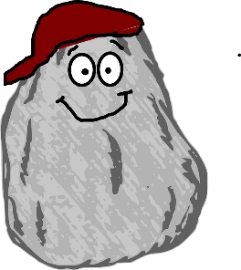
    - (+2) Chemical Formula
    - (+2) Hardness
    - (+2) Density (specific gravity)
    - (+2) Streak
    - (+2) Something “Special” about the mineral
      - (For example, magnetic, color, shape, etc)
    - (+6) 3 Important uses (Complete sentences)
    - (+4) Two Pictures (must be drawn)
    - (+4) Neat and colorful!

2) You may use a variety of sources such as:
    - Magazines
    - Internet sites
    - Books
    - (+4)You must provide a list of your sources!
Use our class website to locate links to help you with the project! Science – Chapter 7!

